### A: EXPLANATION OF CHATBOT FUNCTIONALITIES

The chatbot that I have developed ask a student a series of questions and then provides a possible job they may enjoy based on the responses. Initially, a student is asked what programming language they enjoy and given a list of buttons that can be selected. When a student selects a button the chatbot will ask another impertinent question or provide a recommendation for the student to explore as well as a link describing the job type that was recommended. This chatbot provides students with an excellent opportunity to get feedback on what job they might find enjoyable based on the student’s personal preferences.

### B: COMPUTING JOB TYPES

The following computing job types are used in the chatbot:

1. Software Developer
2. Database Developer
3. Data Scientist
4. Web Developer
5. Mobile App Developer

### C: CHATBOT CODE FILES

<?xml version="1.0" encoding="UTF-8"?>

<aiml>

<category>

<pattern>*</pattern>

<template>Im sorry, I didn't understand that. Do you need help finding a Computer Science career?</template>

</category>

<category>

<pattern>Hi</pattern>

<template>Do you need help finding a Computer Science Career?</template>

</category>

<category>

<pattern>No</pattern>

<template>I'm sorry I could not help you, please close the program.</template>

</category>

<category>

<pattern>Yes</pattern>

<template>Which programming language do you enjoy the most?

<button>

<text>MySQL</text>

<postback>AnswerMySQL</postback>

</button>

<button>

<text>HTML</text>

<postback>AnswerHTML</postback>

</button>

<button>

<text>Java</text>

<postback>AnswerJava</postback>

</button>

<button>

<text>Objective C</text>

<postback>AnswerC</postback>

</button>

<button>

<text>Any</text>

<postback>AnswerAny</postback>

</button>

</template>

</category>

<category>

<pattern>AnswerMySQL</pattern>

<template>Do you enjoy processing raw data?

<button>

<text>Yes</text>

<postback>AnswerYes</postback>

</button>

<button>

<text>No</text>

<postback>AnswerNo</postback>

</button>

</template>

</category>

<category>

<pattern>AnswerYes</pattern>

<template>A career as a Data Scientist might be more suited to your interests. <br></br> <br></br>

Additional information can be found at

<link>

<text>Data Scientist Career Information</text>

<url>https://business.linkedin.com/talent-solutions/resources/how-to-hire-guides/data-scientist/job-description</url>

</link>

<br></br> <br></br>Would you like to explore other career options?</template>

</category>

<category>

<pattern>AnswerNo</pattern>

<template>A career as a Database Developer might be more suited to your interests. <br></br> <br></br>

Additional information can be found at

<link>

<text>Database Developer Career Information</text>

<url>https://www.indeed.com/hire/job-description/database-developer#:~:text=A%20Database%20Developer%2C%20or%20Database,information%20and%20keep%20it%20secure</url>

</link>

<br></br> <br></br> Would you like to explore other career options?</template>

</category>

<category>

<pattern>AnswerHTML</pattern>

<template>A career as a Web Developer might be more suited to your interests. <br></br> <br></br>

Additional information can be found at

<link>

<text>Web Developer Career Information</text>

<url>https://business.linkedin.com/talent-solutions/resources/how-to-hire-guides/web-developer/job-description</url>

</link>

<br></br> <br></br> Would you like to explore other career options?</template>

</category>

<category>

<pattern>AnswerJava</pattern>

<template>A career as a Mobile App Developer might be more suited to your interests. <br></br> <br></br>

<link>

<text>Mobile App Developer Career Information</text>

<url>https://www.indeed.com/career-advice/finding-a-job/what-is-mobile-app-developer</url>

</link>

<br></br> <br></br> Would you like to explore other career options?</template>

</category>

<category>

<pattern>AnswerC</pattern>

<template>A career as a Mobile App Developer might be more suited to your interests. <br></br> <br></br>

<link>

<text>Mobile App Developer Career Information</text>

<url>https://www.indeed.com/career-advice/finding-a-job/what-is-mobile-app-developer</url>

</link>

<br></br> <br></br> Would you like to explore other career options?</template> </category>

<category>

<pattern>AnswerAny</pattern>

<template>A career as a Software Developer might suit your needs. <br></br> <br></br>

<link>

<text>Software Developer Career Information</text>

<url>https://www.computerscience.org/careers/software-developer/</url>

</link>

<br></br> <br></br> Would you like to explore other career options?</template>

</category>

</aiml>

### D: CHATBOT TRAINING CASES

The following two cases were used as training cases for the chatbot:

Case 1: A student has displayed a significant interest in MySQL, but dislikes processing raw data, and wishes to discover potential careers using this language that fits the students preferences. This case was selected because MySQL as a selected option actually asks an additional question as to whether a student enjoys processing raw data or not in the format of Yes or No. If a student selects Yes, Data Scientist is presented as a job type they might be interested in. If a student selects No, then Database Developer is provided. This test case is to verify the no option provides the correct response to the student. In this case the student answered No to the question about enjoying processing raw data and the correct response of Database Developer was provided by the chatbot.

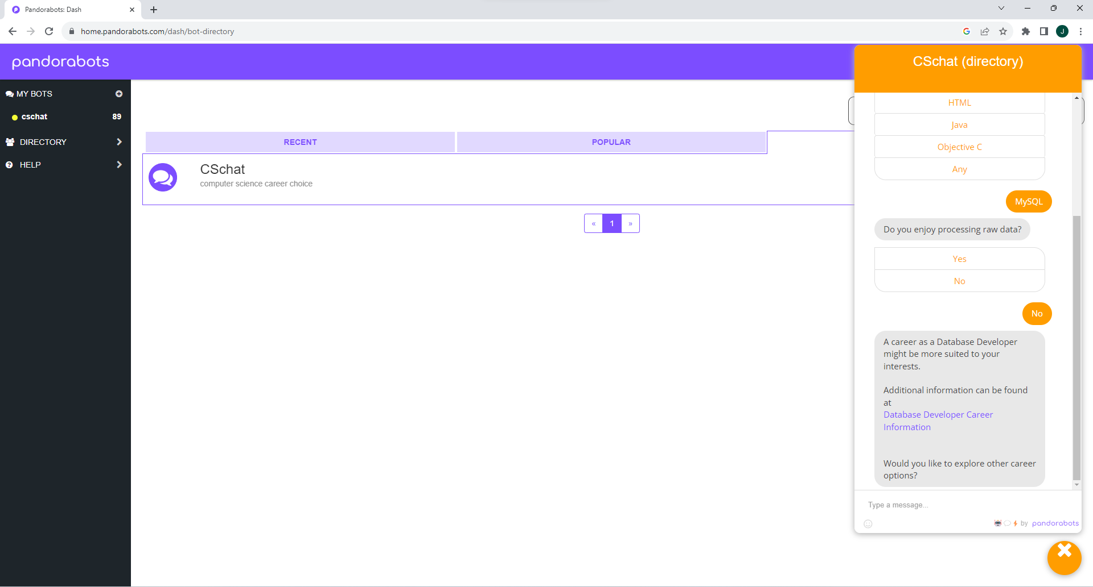

Case 2: A student has shown an interest in programming and has taken the initiative of learning multiple languages on their own. However, they do not favor one programming language over the other and are looking for information on a potential career path they could take. This test case was selected to verify that the Any option for the “Which programming language do you prefer” provides the correct response of Software Developer and provides the proper link that a student can access for additional information. During this test case the student selected the Any response and was correctly directed to Software Developer by the chatbot and provided a link for the student to explore further.

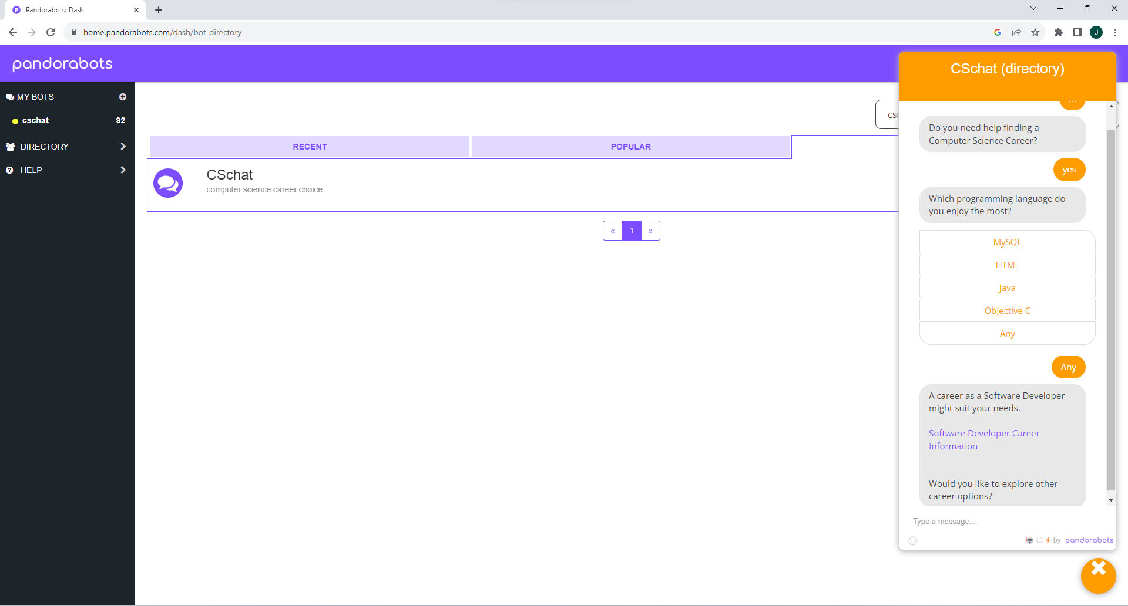

When students utilize the chatbot they are presented with a series of questions. AIML uses those responses to direct the student to a potential career that they might be interested in based on their personal preferences. AIML provides a link that students can explore to learn more about the career the chatbot directed the student to using AIML.

### E: INSTALLATION MANUAL

1. Through a browser, log into pandorabots.com.
2. Go to <https://home.pandorabots.com/dash/bot-directory>
3. Click DIRECTORY, and in the search bar, type “cschat”.
4. Click the yellow chat icon that pups up in the lower right hand corner of the browser.
5. Type “hi” to begin a new session with the chatbot.

### F: CHATBOT ENVIRONMENT

A primary strength of pandorabots as a development environment is the ability to quickly develop chatbots. Pandorabots utilizes AIML, which is a pretty simple and intuitive language. Once you understand the way AIML operates, development is quick and a finished product is produced in a very short amount of time. Another strenght of pandorabots as a development environment is that it is open source, therefore free. Due to this fact a large community has gathered within the web specifically for pandorabots. There is a very large directory of projects created by other individuals that can be viewed at any time to compare your project to or even just to get ideas for future projects.

A primary weakness of the pandorabots development environment is that it only utilizes AIML. This completely eliminates the ability to utilize common machine learning tools that are utilized for artificial intelligence programs in the field. There are many models that would be useful to create a more robust and responsive chatbot if these tools were utilized. Furthermore, a secondary weakness is that there is no intuitive response being generated by the chatbot. The chatbot simply provides a response that is very specific to a user’s response. If that response is off by a single character then the chatbot will not be able to respond to the user’s input with the desired response. The only way to avoid this would be to program categories for every possible user submission possible in the universe, but that is utterly impracticle.

### G: MONITORING AND MAINTAINING

After a student uses the chatbot they will be provided an opportunity to fill out a survey based on their experience with the chatbot. These surveys will be used on many fronts. Firstly, they will provide a basis on user experience and if the experience was positive and useful or not. Secondly, this feedback will provide an opportunity to evaluate the perceived empathy and friendliness of the chat bot. Evaluation of these results will determine changes that need to be made to the chat bot to improve customer experience by providing a more accurate response that displays empathy and friendliness.